**NESPRESSO CORPORATION MARKET RESEARCH PROPOSAL**

**Name: Clare Kuan Sze Sing**

**Student number: 220456793**

**Word count: 2985 (excluding Executive summary, table of content, tables, headings, subheadings, figures, labels, footnotes, legend, appendix, and equations)**

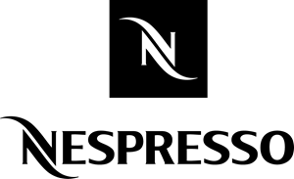

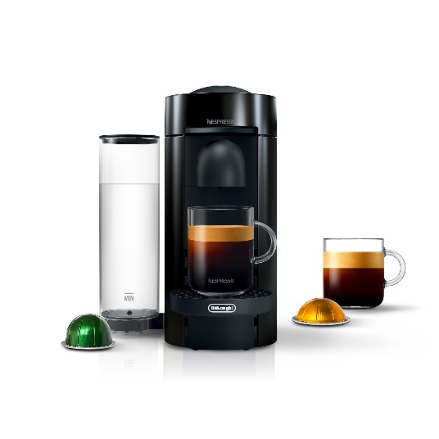

**EXECUTIVE SUMMARY**

Nestlé, a Swiss company that has become a powerhouse in the food and beverage industry in recent times traces its humble beginnings way back to the late 1800s. Its inception was a spark of innovative idea from its founder with this principle remaining as a core staple in its ethos. The continuous dedication to ingenuity in this organisation has led to the formation of Nespresso, which is now a key player in the coffee pod landscape ever since the upward demand from this market.

The purpose of this report is solidifying Nespresso’s position as a figurehead for premium coffee. The centerpiece of this strategy is a dual focus on customer’s preferences and pain points, both aimed at renewing a sense of novelty into Nespresso especially with how competitive the market has gotten. Regardless of which coffee brand respondents consume, a portion on our research will focus on their preferences and norms. Moreover, another crucial objective is evaluating Nespresso’s sustainability initiatives effectiveness and identifying opportunities for growth, sustaining its alignment as an environmentally conscious company.

To achieve these goals, we propose intricate research questions and objectives while utilising various methodologies and sampling method at hand such as convenience, stratified and cluster for robust selection of respondents all paired with a targeted questionnaire.

Following on, we will present a list of statistical techniques tailored to the specific research objectives. Finally, a forecasted timeline, budget and further recommendations are discussed as a guide for the project as well.

In essence, we are confident in Nespresso’s continued dominance over the coffee pod industry. And will be further strengthen by heighten innovation, sustainability actions and an unwavering commitment to high customer experience.

Content Page

1. Introduction 4

1.1: Background Information 4

1.2: Scope of the Problem 5

1.3: Research Aims (RAs) 5

1.4: Research Questions (RQs) 6

1.5: Research Objectives (ROs) 7

2. Methodology 8

2.1: Research Designs and Approaches 8

2.2: Research Approach Used 10

2.3: Statistical Techniques Used 10

3. Data Collection 10

3.1: Primary Data 10

3.2: Secondary Data 11

3.3: Sampling Design 11

3.3.1: Convenience Sampling 12

3.3.2: Stratified Sampling 12

3.3.3: Cluster Sampling 14

3.4: Sample Size Determination 14

3.4.1 Nespresso Customers 14

3.4.2 Non-Nespresso customers 15

4. Data Analysis and Hypothesis 16

4.1: Research Objective 1.1 16

4.2: Research Objective 1.2 19

4.2.1: Levene’s test 21

4.2.2: Independence T-test 22

4.3: Research Objective 2.1 22

4.4: Research Objective 3.1 23

4.4.1: Paired Samples Test 24

4.5: Research Objective 3.2 25

4.5.1: Chi-square test of association 26

4.5.2: Measures of association 27

5. Questionnaire 28

5.1: Taste and Preference Questionnaire 29

5.2: Feedback for Improvement Questionnaire 33

5.3 Consumer Awareness Questionnaire 36

6. Timeline and Budget Details 38

6.1: Timeline 38

6.2: Budget 40

7. Further Research & Recommendations 41

7.1: Customer habits 41

7.2: Social Media 41

8. Flow chart 43

9. Appendix 44

# 1. Introduction

## 1.1: Background Information

Launched in 1986, Nespresso was the brainchild of Eric Favre, a visionary who conceived the unprecedented idea of developing machinery that combines convenience with top-notch quality coffee grounds, allowing users to enjoy effortless coffee preparation at home or work. Nowadays, Nespresso has fully established its presence in the coffee pod market, with recent revenues totaling up to a staggering $10.8bn.[1]

Nespresso offers a variety of pre-ground coffee, tightly encased in minimalistic and portable capsules. Complemented by state-of-the arts machines created to maximise these capsules, it brings the groundbreaking concept to fruition. Furthermore, Nestlé’s original alignment towards sustainability has extended this pledge to Nespresso. They do actively take pride in ethical and eco-friendly sourcing and production of their coffee pods, raising the gold standard bar within the market. This information is easily accessible in their website for all. With the company projecting forward, its central focus of maintaining its foothold on the industry is achieved through prioritising innovation and sustainability.

## 1.2: Scope of the Problem

In the brief, Nespresso mentioned that its main goal is maintaining its leadership in the premium coffee market. To achieve this, Nespresso recognises the importance of emphasising on customer’s preferences and investment in research and development of new coffee blends and brewing technologies. In addition, Nespresso also drives to cultivate an environmentally friendly brand image and thus this proposal will compile relevant information and outline strategies that aid in Nespresso’s business aims.

## 1.3: Research Aims (RAs)

The client brief identifies three research aims that encapsulate Nespresso’s main concerns.

* **RA 1:** We want to accurately understand customer’s preferences for new coffee blends and new brewing technologies
* **RA 2:** We want to understand customer’s pain points to identify areas of improvement in product quality, packaging and customer services
* **RA 3:** We also want to evaluate the effectiveness of its sustainability initiatives and identify opportunities for further improvement

## 1.4: Research Questions (RQs)

To have more clarity regarding the research aims, we have broken them down into research questions, providing food for thought on Nespresso’s key concerns.

**For RA 1:**

* **RQ 1.1:** How does different demographic of customers affect customers preferences to new coffee blends?
* **RQ 1.2:** How does household size affect preference for new brewing technologies?

**For RA 2:**

* **RQ 2.1:** What are the possible improvements in product quality, packaging and customer services based on the customer feedback?

**For RA 3:**

* **RQ 3.1:** How effective has the capsules been in achieving Nespresso’s sustainability goals
* **RQ 3.2:** How is consumer’s awareness to sustainability initiatives affected by their education level?

## 1.5: Research Objectives (ROs)

From the research questions, we can further delve into their respective research objectives to tackle the underlying issues.

**For RQ 1.1:**

* **RO 1.1:** Examine the relationship between different coffee blends with the different demographic variable of customers: age group, gender and annual income

**For RQ 1.2:**

* **RO 1.2:** Investigate the relationship between household size of customers with preferences of new brewing technologies

**For RQ 2.1:**

* **RO 2.1:** Evaluate how customer’s overall satisfaction with the product quality, packaging and customer services can help identify the areas of improvement that can be made

**For RQ 3.1:**

* **RO 3.1:** Determine if the environmentally friendly capsules has effectively increased customers awareness about the sustainability initiatives

**For RQ 3.2:**

* **RO 3.2:** Investigate if there is a relationship between the customers awareness of the sustainability initiatives and their education level

# 2. Methodology

## 2.1: Research Designs and Approaches

In this proposal, we designed the market research objectives to incorporate the three main research designs, Exploratory, Descriptive and Causal.

Exploratory research is used to gauge of customer’s satisfaction with Nespresso’s products and services, enabling us to acquire detailed insights into possible area of improvements. Since ones preferences are so volatile, we chose such an approach as we lack up to date information.

Descriptive research identifies or describes patterns among various market characteristics. It formulates a sound relationship between customer demographics with the different variables by effectively summing up the data collected.

Causal research is used to collect evidence of a cause-and effect dynamic. It helps streamline the comparison of awareness levels before and after the sustainability initiatives, making it easier for us to pin point successful campaigns and their impact.

To capture the story told, we will utilise both the Quantitative and Qualitative approach. Surveys and designed focus groups will serve as outlets to execute these approaches respectively. Quantitative data is numerical and measurable while Qualitative is data that needs interpretation due to its open-ended nature.

RO 1.1 and 3.1 will engage in the Quantitative approach, primarily using surveys for data collection. We allocated this approach as numerical data is essential to verify our hypothesis concerning one the relationship between coffee blends and varying variables for 1.1 and two differences in level of awareness for 3,1 .

On the other hand, we will largely apply the Qualitative approach to RO 2.1, using both survey and focus groups in tandem for effective data collection. While empirical data is needed to clearly see customers overall satisfaction, in this scenario we mainly require an added focus group designed for customers to share their experiences. The integration of two methods helps to paint a better picture of customer’s pain point and satisfaction of Nespresso’s products and services, allowing easier identification of areas on improvement and understanding of their behaviour.

To maximise time and cost efficiency, we propose conducting the survey and focus group online, with added bonuses of a larger sample size. To encourage ample participation, we have plans to allocate some of Nespresso’s big budget toward gift cards given as incentives to the participants.

## 2.2: Research Approach Used

**For Quantitative:**

* RO 1.1
* RO 1.2
* RO 2.1
* RO 3.1
* RO 3.2

**For Qualitative:**

* RO 2.1

## 2.3: Statistical Techniques Used

* RO 1.1: Multiple Linear Regression with dummy variable
* RO 1.2: 1- way ANOVA
* RO 2.1: Focus group
* RO 3.1: Paired t-test with Quasi-experimental design
* RO 3.2: Chi-square test of association using tau-b

# 3. Data Collection

## 3.1: Primary Data

|  |  |
| --- | --- |
| Variables | Classification |
| Different demographic of customer:  : Age group  : Gender  : Annual income  : Household size  Y: Preference to new coffee blends | : Categorical Ordinal  : Categorical Nominal  : Continuous  : Continuous  Y: Continuous |
| : Household size  Y: Preference to new brewing technologies | : Categorical Ordinal  Y: Continuous |
| Preference rating for different variables[2]:  : Ratings on packaging  : Ratings on product quality  : Ratings on customer services | to : 5 point Likert scale |
| Y: Consumer awareness[3] | Y: Continuous |

## 3.2: Secondary Data[4]

|  |  |
| --- | --- |
| Variables | Classification |
| Y: Consumer awareness | Y: Continuous |
| : Education level  Y: Consumer awareness | : Categorical Ordinal  Y: Categorical Ordinal |

## 3.3: Sampling Design

For this market research, we propose to use three samplings techniques:

1. Convenience
2. Stratified Convenience
3. Cluster

One each for each questionnaire created.

## 3.3.1: Convenience Sampling

Convenience sampling involves selecting respondents through convenient means. In Section 5.1, questionnaire uses this strategic approach is a cost and time effective way to survey diverse demographics of respondents regardless of their coffee consumption frequency or their status as Nespresso customers. Such method enables a deeper understanding of the target audience’s preferences.

## 3.3.2: Stratified Sampling

Stratified sampling involves the subdividing of the main population into smaller and distinct strata[5]. Data in each stratum is collected through randomisation, ensuring high level of precision in representation. This sampling technique enables us to outline different strata based on their grouped specific characteristics, showing off a diversified response.

In the context of our research, the key stratum includes product packaging, product quality and customer services. Section 5.2 of the proposal will contain more information on how we will survey the stratum through an online questionnaire.

## 3.3.3: Cluster Sampling

Cluster sampling refers to the division of target population into mutually exclusive and collectively exhaustive clusters. Afterwards in Section 5.3 we will then employ a random selection process to choose specific clusters from the subsets as our overall sample representation. This approach being cost effective and easy to implement helps us to collect data on demographics and level of awareness much more efficiently than other methods.

## 3.4: Sample Size Determination

Based on the client brief, Nespresso would like to have a minimum of 5,000 of Nespresso customers segmented appropriately. We would like to suggest a sample size that adheres in showing significance whilst keeping cost optimised. At 95% confidence level, our target sample size requires accuracy within ±0.05 of the true population proportion. As such, minimum sample size required would be:

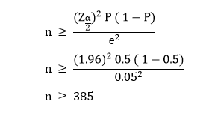

## 3.4.1 Nespresso Customers

We are aware, average response of online survey hovers around 44%[6]. We estimate a 20-30% increase in response rate due to the added incentives. Our estimated incidence rate is 90% with a 70% completion rate.



To ensure reliable data, we will take n = 611 as sample size for 1 region. In total, there are 4 regions. We selected these regions due to high population density, eluding to a higher percent of respondents being Nespresso customers. The regions[7] are

* Asia
* Africa
* Europe
* North America

Total minimum sample size would be 4n = 2,444.

## 3.4.2 Non-Nespresso customers

Given that the sample size for competitive customers is unknown, we can surmise that its total minimum sample size is around 2,029.

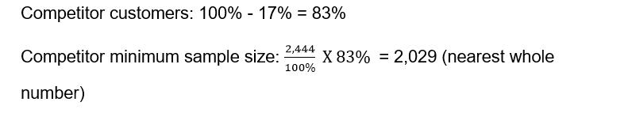

This estimated number is achieved via a look into coffee pods market share[8]. In it, Nespresso accounts for 17% of total market share

It is worth noting that, actual sample size for both populations could differ due multitude of factors and the final decision will be in Nespresso’s hands. In addition, Section 5.1 will have a larger sample size due to integration of both customer groups.

# 4. Data Analysis and Hypothesis

## 4.1: Research Objective 1.1

This RO requires the usage of Multiple Linear Regression (MLR) to examine the effects of independent variables on this objective’s dependent variable. The independent variables are age group, gender and annual income while the dependent variable is customer’s preferences for new coffee blends and brewing technologies. The MLR function formulated is:

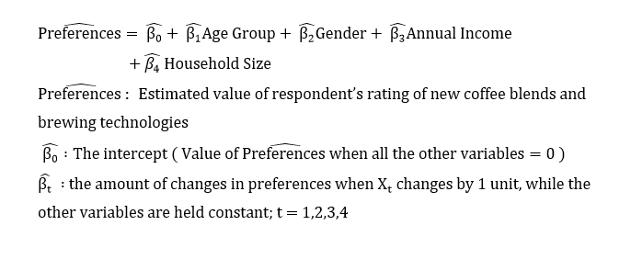

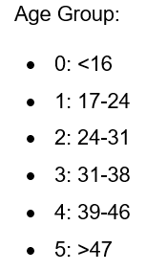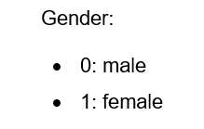

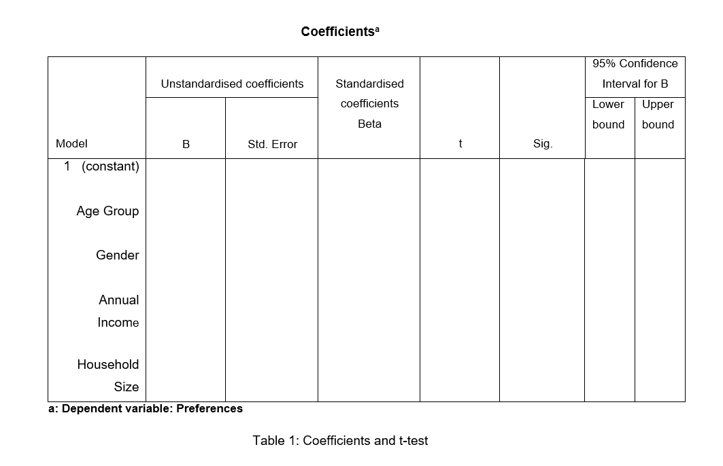

From the SPSS, we would conduct both a Partial t-test and an F-test to assess the significance of the variables.

The F-test allows us to examine whether all the independent variables as a whole possess regression coefficients ( not equal to 0.

The Partial t-test allows us to specially look into individual independent variables and check if its regression coefficient does equal to 0. With reference to Table 1, 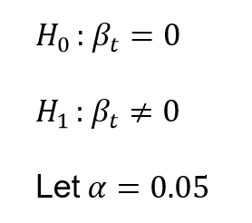

If the individual variable’s “sig.” is < 0.05, we reject and we will be able to conclude that that associated variable contributes significantly in terms of predicting power to the model that already consists of the other independent variables.

Next, we would turn to the Adjusted R2 table in Table 2 to estimate an overall goodness of fit based on the number of independent variables. This helps us to better assess the model’s effectiveness in relation to the individual predictors, where a larger R2 indicates a better-fitted model.

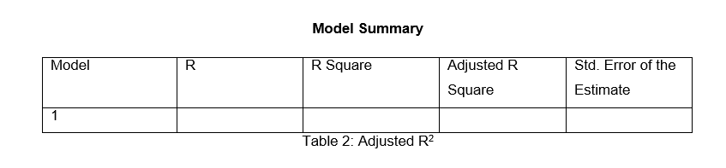

## 4.2: Research Objective 1.2

To tackle this RO, we will be conducting a 1-way ANOVA. It is an efficient method of comparing different means and variances across varying independent sub groups of a variable. With the independent variable being household size and the dependent variable being preferences for new brewing technologies, we would like to test whether the customer’s household size actually influences customer’s preferences in new brewing technologies.

Since the sample size is large, we can ignore the normality assumption and conduct both a Levene’s test and the ANOVA test.

The table below is a summary of the different variables used and their accompanied symbols:

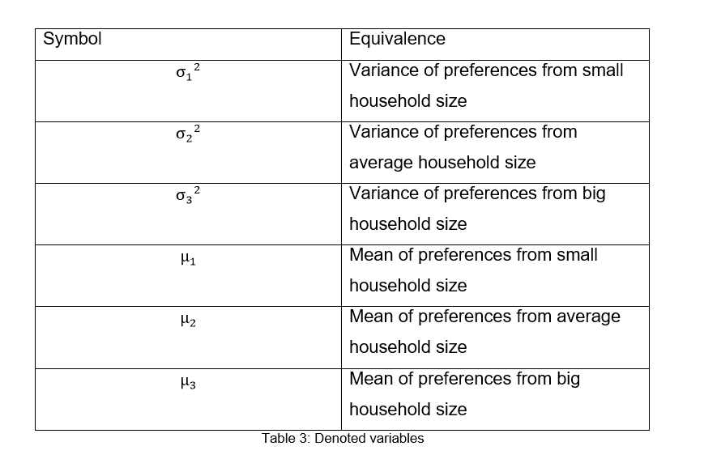

To clarify, we categorise household sizes as categorical variables, placing the continuous data collected into three main categories of small, average and big for the ANOVA table. The global average family size fluctuates around 3-4 people[9] and thus that will be our own average household size indication with anything lower or higher to be categorised into small and big respectively.

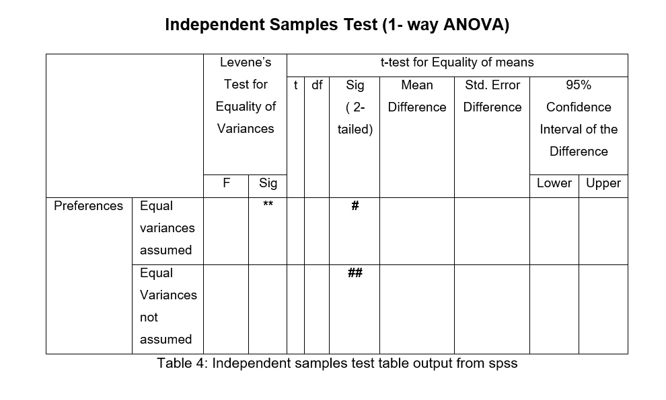

## 4.2.1: Levene’s test

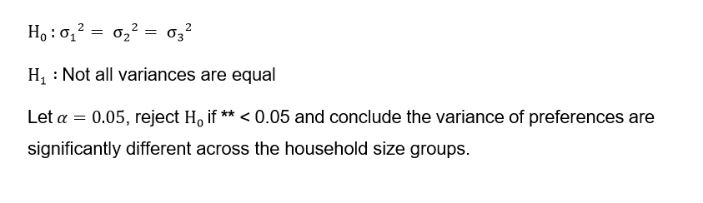

## 

## 4.2.2: Independence T-test

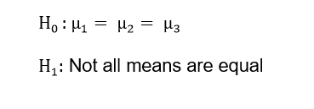

Let, reject if **##** < 0.05 and conclude not all means are equal. Moreover, if both upper and lower bound of the confidence interval exhibits positive values, it means different household sizes gave higher ratings compared to the other two.

## 4.3: Research Objective 2.1[10]

For this RO, we will hold a secured online focus group to explore respondents’ response and experiences. A targeted questionnaire with a section to express interest in the focus group will precede the session. Refer Section 5.2 for further information.

To elaborate on the logistics of the focus group, firstly, there will be maximum 30 small focus groups of around 6 participants assigned to different days or timings, allowing ample time for each individual to share their thoughts adequately. A skilled moderator will be present at all times, lasting approximately an hour long for each group. The moderator has to ensure seamless discussion and adhere to the topic while providing probing questions such as “Can you recalled any specific challenges you faced while using the product?” There will be an encrypted recording and transcript of the focus groups for future references when categorising the responses.

## 4.4: Research Objective 3.1

To reiterate, the primary goal of this research objective is examining differences in consumer’s awareness of Nespresso’s sustainability initiatives. Therefore, a three-pronged approach will be adopted – a Quasi-experimental design paired with cluster sampling and a paired t-test, representing the difference,

Firstly, we use Cluster sampling to narrow down sample size into manageable numbers. Next, we issue the questionnaire to the selected clusters and this is where the Quasi-experiment comes in. Since the independent variable is awareness, we naturally group[11] respondents into either aware or unaware. The two-step process aims to access the success of Nespresso’s environmentally friendly capsules on promoting their sustainability initiatives.

At the end of the data collection process, a paired t-test methodology will be utilised to visualise significance of results.

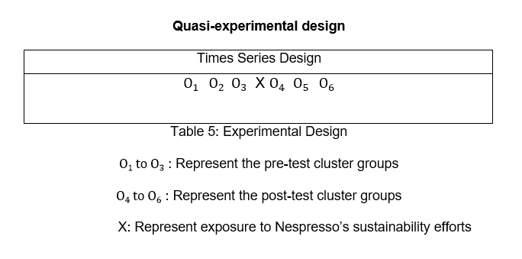

## 4.4.1: Paired Samples Test

To precisely determine the potential impact of Nespresso’s environmentally friendly capsules on consumer’s awareness of Nespressso’s sustainability initiatives, we will conduct a paired samples t test. Since the sample size is large enough, we can safely ignore the normality assumption

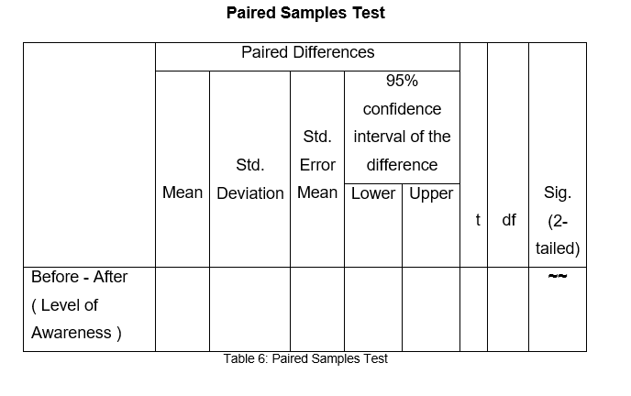

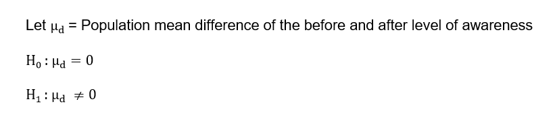

Let, reject if **~~** < 0.05, and conclude that the environmental capsules does seem to result in a significant difference in level of awareness. This can be supported by the 95% confidence interval of the difference if its lower and upper bound doesn’t include zero and endpoints are both negative

## 4.5: Research Objective 3.2

In response to this RO, we will conduct a Chi-Square test of association. This technique helps to determine whether there is an underlying relationship between two categorical variables. Circling back to the RO itself, our aim is to establish a relationship between education level and customer’s level of awareness. We will gather data on education level from both the Questionnaire in Section 5.3 and previously data stored in Nespresso’s database.

## 4.5.1: Chi-square test of association

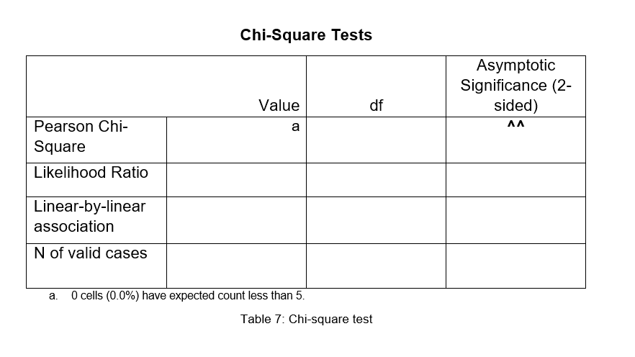

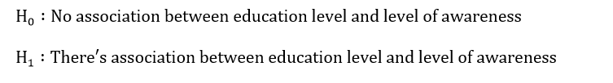

From the chi-square test table, there were 0 cells with expected count less than 5 hence the statistically result of this test is reliable.

Let, reject if **^^** < 0.05 and conclude that there is a significant association between education level and level of awareness.

## 4.5.2: Measures of association

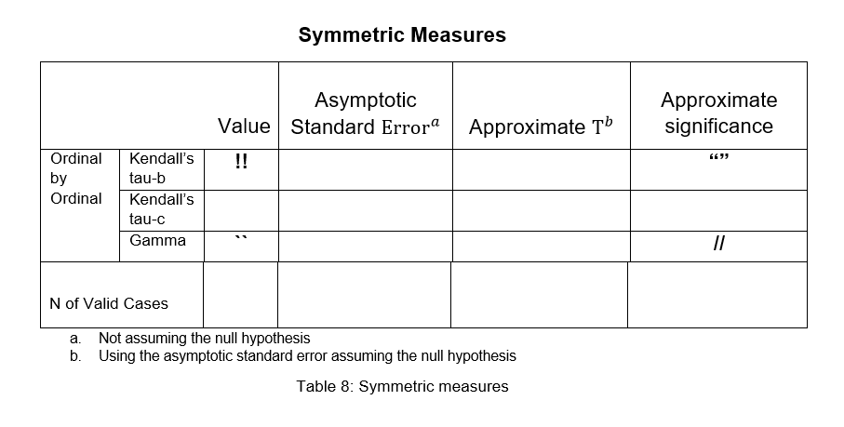

Since the above table is a 4x4, we can ignore the Kendall’s tau-c.

Tau-b = **!!** , p-value = **“”**

The strength of association between these two categorical ordinal variables depends on how close **!!** is to **“”**. The direction of associations, whether positive or negative is determined by the sign of **!!**, which can be either signal a positive or negative integer respectively.

Gamma = **``**, p-value = **//**

Gamma enables us to determine the percentage improvement in predicting the dependent variable (Level of Awareness) with the independent variable (Education Level). The **``** value will be converted to represent this percentage.

# 5. Questionnaire

As a follow up to Section 3.3, below are additional notes.

The primary objective of Section 5.1 aims to comprehensively understand and analyse coffee drinkers’ current preferences. They include both Nespresso and competitor customers. We strive to uncover patterns and relationships between the respondents’ preferences and their categorised stratum, providing insights for future decision-making to attune to their palettes.

While for Section 5.2, our objective is eliciting honest feedback about customers’ experiences with Nespresso through targeted questions pinpointing areas of dissatisfaction for genuine improvements. An interest form at the end of the Questionnaire allows participants to express interest in joining the online focus group, facilitating prompt gathering of detailed opinions and experiences.

The Questionnaire in Section 5.3 will rely on the basic demographic questions already answered in Section 5.1 but with one to two additional differentiating demographic questions. This Questionnaire mainly consists of questions pertaining to their own knowledge of Nespresso’s sustainability initiatives. By exploring these aspects, we gain insights into Nespresso’s effectiveness in communicating and promoting their sustainability initiatives and confirming the public’s perception of Nespresso as an eco-friendly company.

## 5.1: Taste and Preference Questionnaire

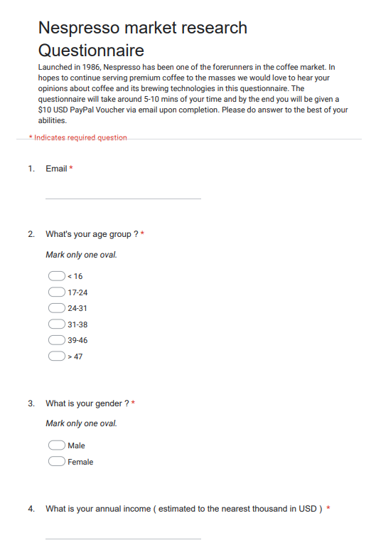

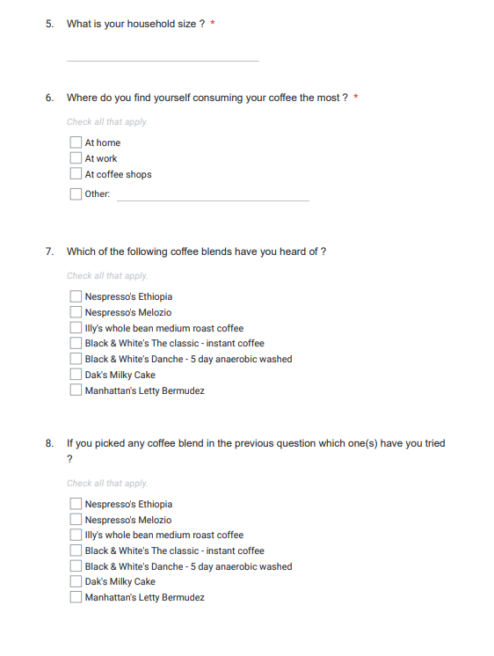

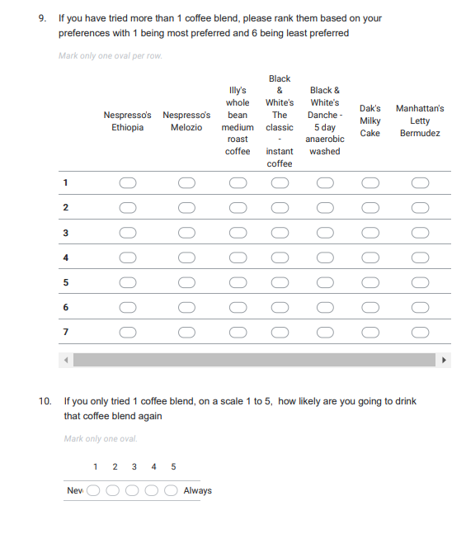

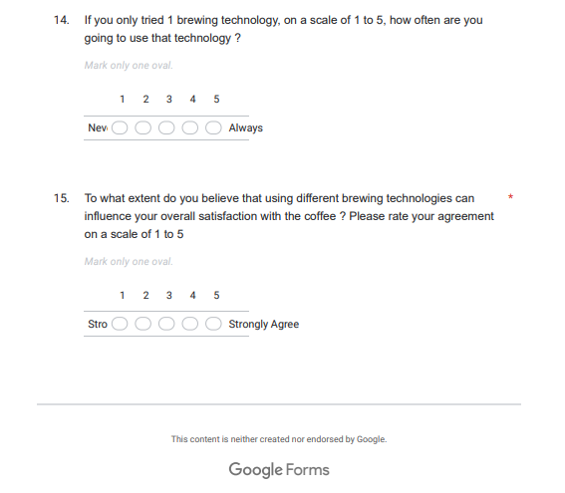

## 5.2: Feedback for Improvement Questionnaire

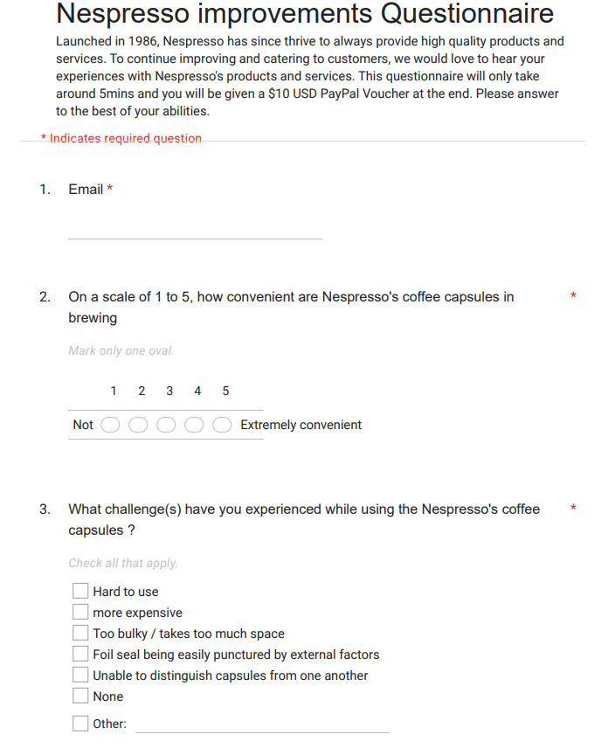

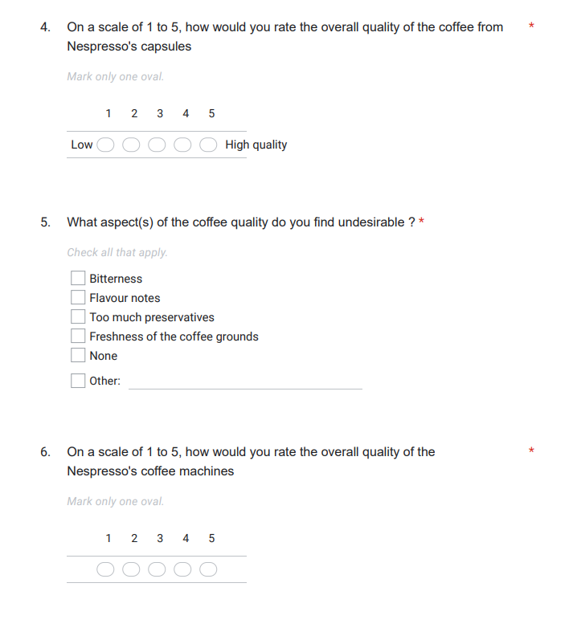

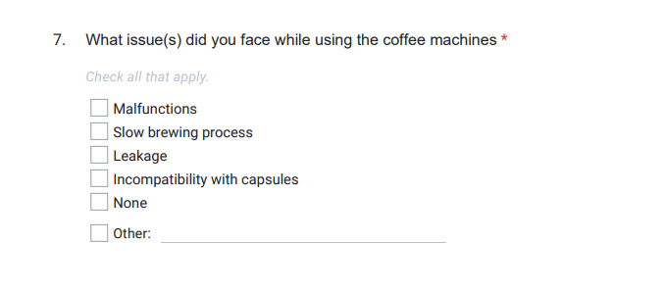

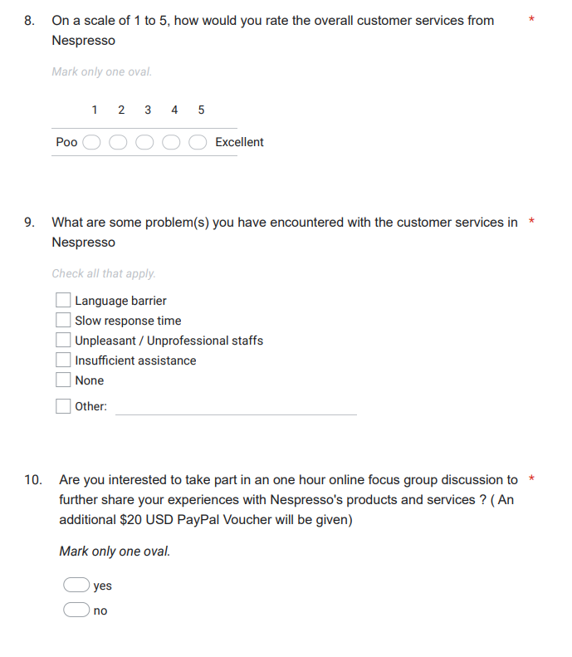

## 5.3 Consumer Awareness Questionnaire

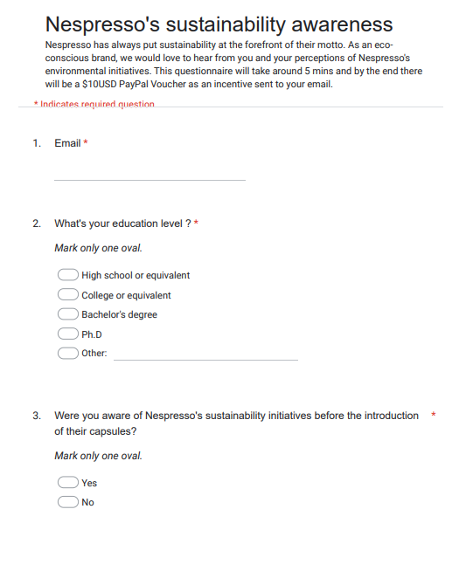

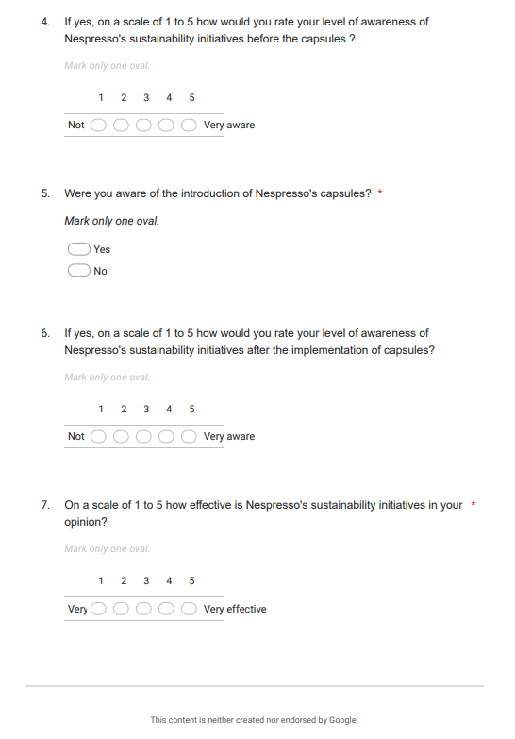

# 6. Timeline and Budget Details

## 6.1: Timeline

The project will commence immediately upon approval. Nespresso has allocated us a 6-month window to complete the project and thus we have created a timeline to provide clear visualization of our project outline. Please find the proposed timeline below:

**Gantt chart**

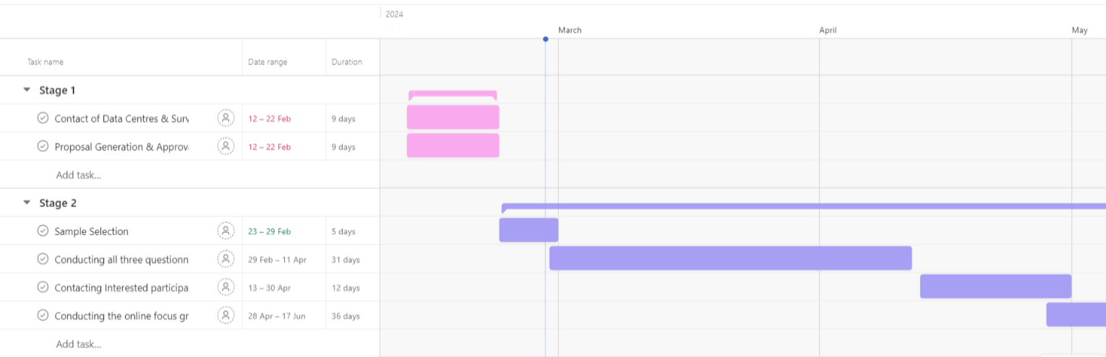

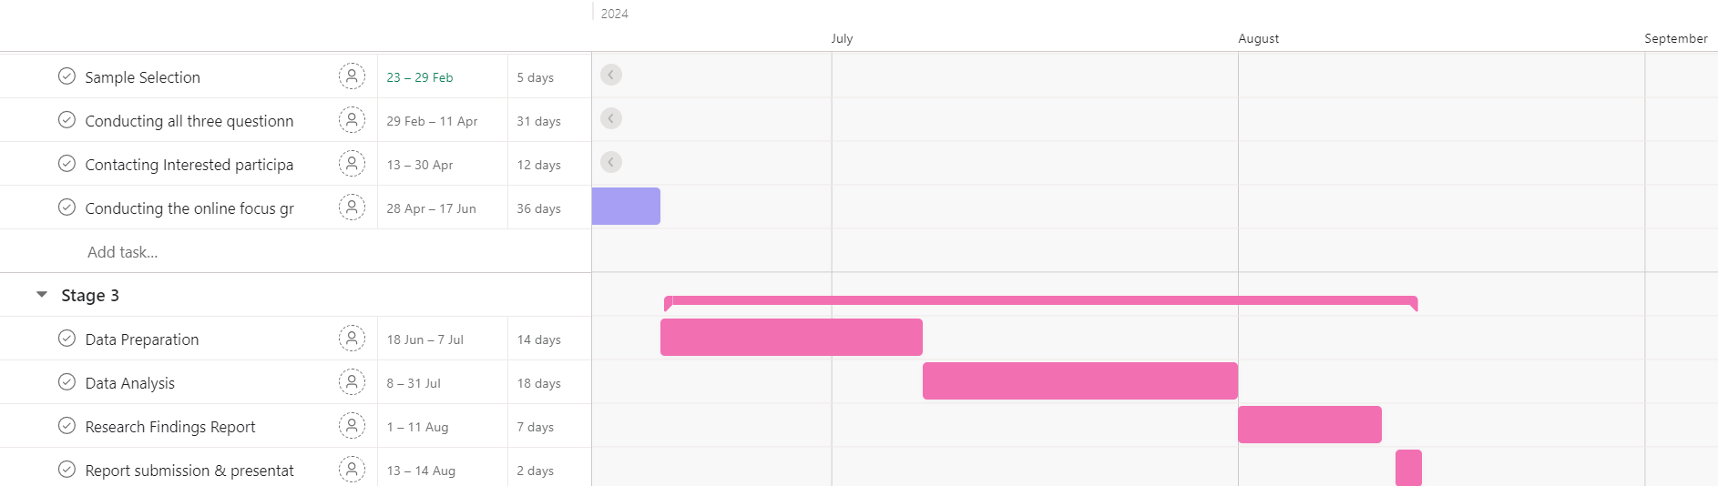

Figure 1: Gantt chart of proposed timeline in 6 months

**Quick summary of the timeline[12]**

|  |  |  |
| --- | --- | --- |
| Stage 1 | Stage 2 | Stage 3 |
| 1. Contact of Data Center & Services **( 9 days )** | 1. Sample Selection **( 5 days )** | 1. Data Preparation **( 14 days )** |
| 2. Proposal Generation & Approval **( 9 days )** | 2. Conducting both market research, improvements & customer awareness Questionnaire **( 31 days )** | 2. Data Analysis **( 18 days )** |
|  | 3. Contacting interested participants of the online focus group **( 12 days )** | 3. Research Findings Report **( 7 days )** |
| 4. Conducting the online focus group **( 36 days )** | 4. Report submission & presentation **( 2 day )** |

Table 7: Summary of timeline of events with estimated days attached

While our proposed timeline may not fully utilise the 6 months window, this intentional method allows for leeway and flexibility in case of unprecedented events occurring during the course of the project. Ideally, the project will start on 23 Feb and conclude by 14 Aug of the same year.

## 6.2: Budget

**Budget distribution pie chart**

Figure 2: Estimated cost of project and data collection

# 7. Further Research & Recommendations

## 7.1: Customer habits

Nespresso renowned for its convenient coffee stands as a main choice for coffee drinkers needing a quick caffeine boost. While their first cup fuels their mornings, they lack to consider the afternoon slump that often occurs after lunch where tiredness sets in once again.[13] Recognising such patterns and a craving for caffeine and sugar to stay awake, Nespresso can leverage on their Melozio coffee to combat this body phenomenon. Nespresso can introduce new recipes with higher caffeine or natural sugars[14]. A solution to combat lethargy combined with the promise of convenience, creates a lock-in mechanism for the consumers, effectively cultivating brand loyalty. The impact is most prevalent in workplace where coffee offers a more time effective solution than a power nap.

## 7.2: Social Media

Well we are aware of Nespresso’s existing social media presence, we do recommend further research into fully utilising social media accounts like Tik-Tok, as it can be a game changer. For Tik-Tok, the app has shown far more exponential growth than other platforms[15] and Nespresso can capitalise on that figure to connect with an untapped demographic of coffee drinkers.

A look into Nespresso’s Tik-Tok, we can observe that their social media platform is highly curated to attract a classier, older and affluent group of people. Even though this approach has worked, Nespresso is actually alienating a much young and chronically online generation who are now financially capable to own a Nespresso coffee machine.

Hence, Nespresso needs to start marketing outside their core customers while maintaining the older customer base. Engaging in simple viral trends can capture Gen Zs attention while not being too obnoxious for their pre-existing mature customers. While Nespresso currently utilises influencers for promotion, there’s still a need for an eye-catching media feed to retain Gen Z audiences.

# 8. Flow chart

START

Figure 3: Flow chart of procedure

End. Incentives send to respondent’s email

Improvement Questionnaire ($10USD)

Focus Group ($20USD)

Interested in joining focus group

Awareness Questionnaire ($10USD)

Non-Nespresso customer

Nespresso customer

Preferences Questionnaire ($10USD)

# 9. Appendix

(Ed cumming , 2020) How Nespresso's coffee revolution got ground down. The guardian. Available at: <https://www.theguardian.com/food/2020/jul/14/nespresso-coffee-capsule-pods-branding-clooney-nestle-recycling-environment>

(Meng-Jia Wu , Kelly Zhao , Francisca Fils-Aime , 2022) Computers in Human Behavior Reports; Response rates of online surveys in published research: A meta-analysis.

Available at:

<https://www.sciencedirect.com/science/article/pii/S2451958822000409>

(World Population Review , 2024) Population by Continent 2024. Available at: <https://worldpopulationreview.com/continents>

(Eva Hart, 2023) Amazon Market Watch: Starbucks is Losing Market Share while Lavazza Rises Above. Available at: <https://www.junglescout.com/blog/amazon-market-watch-coffee-product-sales/>

(Isabel Griffith, Jenita Parekh, Chris Charles, 2020) Conducting Successful Virtual Focus Groups. Available at: <https://www.childtrends.org/publications/conducting-successful-virtual-focus-groups>

(Lydia Kang, MD, 2022) Ask a Doctor: Why do I get sleepy in the afternoon after eating lunch? The Washington Post.

Available at: <https://www.washingtonpost.com/wellness/2022/09/26/tired-sleepy-after-lunch-afternoon/>

(C Mandler, 2023) Percentage of TikTok users who get their news from the app has nearly doubled since 2020, new survey shows. Available at: <https://www.cbsnews.com/news/number-of-people-getting-news-from-tiktok-doubled-since-2020-pew-research/>

(Nespresso) Frequently Asked Questions: Do Nespresso capsules (Original or Vertuo) contain sugar?

Available at:

<https://www.contact.nespresso.com/faq/mx/en/detail/6178#:~:text=Nespresso%20Family%20capsules%20do%20not,or%20in%20some%20indulgent%20recipe>.

**Images used:**

Nespresso logo, available at:

<https://upload.wikimedia.org/wikipedia/commons/4/4e/Nespresso_logo_%28monogram_%2B_wordmark%29.svg>

Nespresso’s machine and pods, available at:

<https://i5.walmartimages.com/seo/Nespresso-Vertuo-Plus-Coffee-and-Espresso-Maker-by-De-Longhi-Black_b80b2bf3-f47c-494d-be9c-bd5b548760f9.b4bcbb88b02aaef77b5df4c697c22ab4.jpeg>

1. https://www.theguardian.com/food/2020/jul/14/nespresso-coffee-capsule-pods-branding-clooney-nestle-recycling-environment
2. Rating system derived from the Questionnaire for improvements
3. Consumer awareness derived from after the implementation of the sustainability initiatives. This data needs to be collected as a new set
4. Includes data previously collected, stored in database
5. Subpopulations
6. https://www.sciencedirect.com/science/article/pii/S2451958822000409
7. https://worldpopulationreview.com/continents
8. https://www.junglescout.com/blog/amazon-market-watch-coffee-product-sales/
9. https://worldpopulationreview.com/country-rankings/family-size-by-country
10. https://www.childtrends.org/publications/conducting-successful-virtual-focus-groups
11. Not randomly assigned
12. The days font colour are coloured according their respective stages block in Figure 1
13. https://www.washingtonpost.com/wellness/2022/09/26/tired-sleepy-after-lunch-afternoon/
14. Nespresso does not have added sugars or sweeteners; source: https://www.contact.nespresso.com/faq/mx/en/detail/6178#:~:text=Nespresso%20Family%20capsules%20do%20not,or%20in%20some%20indulgent%20recipe.
15. https://www.cbsnews.com/news/number-of-people-getting-news-from-tiktok-doubled-since-2020-pew-research/